Book list

Dr. Kane
Parenting Gifted Children: Spotlight on Social and Emotional Characteristics

Living With Intensity: Understanding the Sensitivity, Excitability, and the Emotional Development of Gifted Children, Adolescents, and Adults by Susan Daniels & Michael M. Piechowski

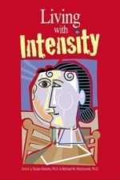 November 2008

Giftedness 101 (The Psych 101 Series) by Linda Kreger Silverman
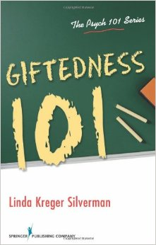December 2012

Mellow Out, They Say. If I Only Could: Intensities and Sensitivities of the Young and Bright by Michael M. Piechowski

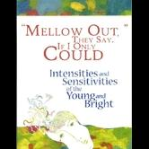 March 2006

Off the Charts: Asynchrony and the Gifted Child by Christine S. Neville, Michael M. Piechowski & Stephanie S. Tolan

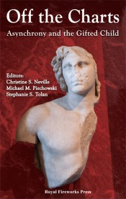2013

